Producer Report 3 for B-tree Visualization Project

Director: Samuel Morrison

Producer: Brayden Peck

Other team members: Conley O'Neill, Thomas Wood

# Section 1 Current Tasks

Tasks for this period.

|  |  |  |  |  |  |
| --- | --- | --- | --- | --- | --- |
| Task | Complete/Incomplete | Assigned to | Start Date | Time spent (total) | Comments |
| 1)  Recode existing code in C++ | Incomplete | All | 9/2 | ~40 | This part took much longer than expected to get the b tree classes working in C++ |
| 1.1)  Complete B Tree Data Structure | Incomplete | Brayden | 9/2 |  | Waiting on the B tree methods to be completed |
| 1.1.1)  Search method B tree | Incomplete | Brayden | 9/2 | ~ | This is blocked until the insert method is working properly |
| 1.1.2)  Insert method B tree | Incomplete | Brayden | 9/2 | 8 | This method is mostly working but there is still some bugs that need to be sorted out |
| 1.1.3)  Delete method B tree | Incomplete | Brayden | 9/2 | 2 | This is blocked until the insert method is working properly |
| 1.2)  Complete B+ Tree Data Structure | Complete | Samuel | 9/2 | ~23 | This data structure is completed |
| 1.2.1)  Search method B+ tree | Complete | Samuel | 9/2 | 1 | This method is completed |
| 1.2.2)  Delete method B+ tree | Complete | Samuel | 9/2 | 15 | This method is completed |
| 1.3)  Complete B* Tree Data Structure | Complete | Samuel | 9/2 | 1.5 | This data Structure is completed |
| 1.3.1)  Search method B* tree | Complete | Samuel | 9/2 | .5 | This method is completed |
| 1.3.2)  Delete method B* tree | Complete | Samuel | 9/2 | .5 | This method is completed |
| 1.3.3)  Insert method B* Tree | Complete | Samuel | 9/2 | .5 | This method is completed |
| 1.4)  Link to GUI Backend | Incomplete | Conley, Thomas | 10/11 | 4.5 | This is Blocked until the B Tree is complete |
| 1.5) Display Data structures | Incomplete | Conley, Thomas | 10/11 | ~18 |  |
| 1.5.1)  Insert Cells | Incomplete | Conley, Thomas | 10/11 | 5 | Still working on getting cells to insert without overlaps |
| 1.5.1.1)  Create new Cells | Complete | Conley, Thomas | 10/11 | 2 | Cells can be created with items added |
| 1.5.1.2)  Insert Child Cells | Complete | Conley, Thomas | 10/11 | 2 | Cells can be inserted under other cells |
| 1.5.1.3)  Layout Cells | Incomplete | Conley, Thomas | 10/11 | 1 | Working on getting cells inserted without overlap |
| 1.5.2)  Animate Actions | Incomplete | Conley, Thomas | 10/11 | 13 | Still working on animations |

# Section 2 Completed Tasks

Completed tasks:

|  |  |  |  |  |
| --- | --- | --- | --- | --- |
| Task | Assigned to | Estimated completion time | Actual completion time | Start Date |
| B+ Tree Delete | Samuel | 25 | ~23 | 9/2 |
| B+ Tree Search | Samuel | 1 | 1 | 9/2 |
| B+ Tree | Samuel | 12 | 15 | 9/2 |
| B* Tree Insert | Samuel | 9 | .5 | 9/2 |
| B* Tree Delete | Samuel | 10 | .5 | 9/2 |
| B* Tree Search | Samuel | 1 | .5 | 9/2 |
| B* Tree | Samuel | 20 | 1.5 | 9/2 |

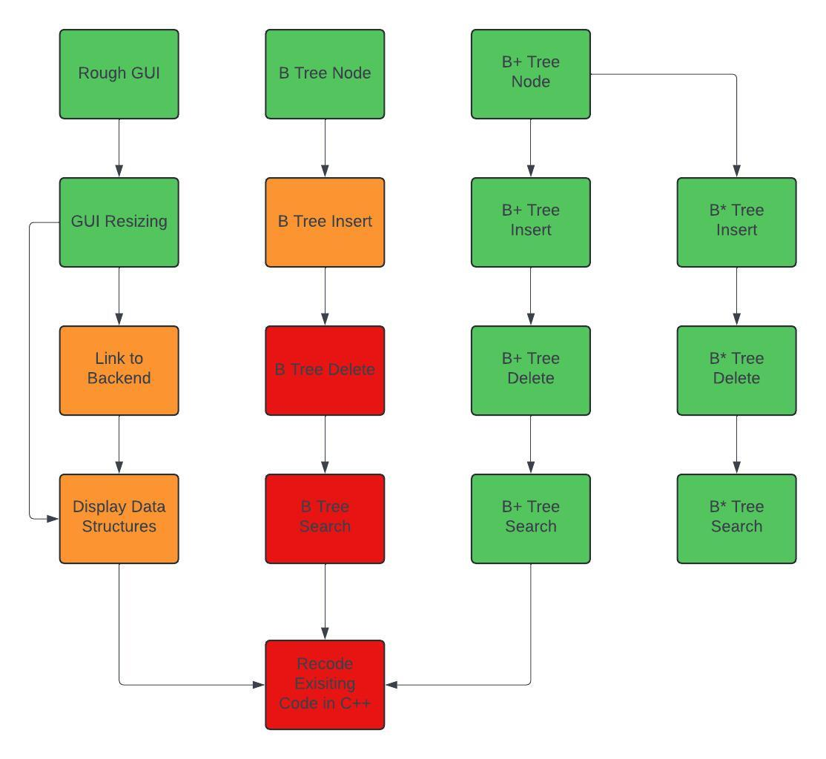

Meeting schedule

|  |  |  |
| --- | --- | --- |
| Date | Time | Attendance |
| 9/20 | 8:00am – 8:50am | All |
| 9/23 | 8:00am – 8:50am | All |
| 9/25 | 8:00am – 8:50am | All |
| 9/27 | 8:00am – 8:50am | All |
| 9/30 | 8:00am – 8:50am | All |
| 10/2 | 8:00am – 8:50am | All |
| 10/4 | 8:00am – 8:50am | Brayden Samuel Conley |
| 10/7 | 8:00am – 8:50am | Brayden Samuel Conley |
| 10/9 | 8:00am – 8:50am | All |

# Section 3 Incomplete Tasks

1) recode existing codebase

1.1) Complete B Tree

1.1.1 ) B Tree Search ( Complete but waiting on insert to test for bugs)

1.1.2 ) B Tree insert (incomplete) bugfixing the last child node

1.1.3)B Tree Delete (complete) waiting on insert to be fixed for testing

1.4) Link to backend(incomplete) waiting on B Tree

1.5) Display data structures(incomplete)

1.5.1) insert cells (incomplete)

1.5.1.3) Layout cells(incomplete)

1.5.2) Animate Actions

# Section 4 Upcoming Tasks

Upcoming / Incomplete tasks

|  |  |  |  |
| --- | --- | --- | --- |
| Task | Assigned to | Estimated Time Spent | Estimated Start Date |
| Search method B tree | Brayden | 5 | 9/2 |
| Insert method B tree | Brayden | 5 | 9/2 |
| Delete method B tree | Brayden | 5 | 9/2 |
| Linking GUI to Code backend (no display) | Conley, Thomas | 2 | 10/11 |
| Display Data Structures in GUI | Conley, Thomas | 10 | 10/11 |
| Display Data Structures | Conley, Thomas | 10 | 11/1 |
| Animate Actions | Conley, Thomas | 10 | 11/1 |